This section will explore the background research that forms the basis of this project. It will explain what is meant by Natural Language Processing, give a brief history of the field along with explanations of some of the key terms and tasks involved in the implementation of this project.

Natural Language Processing

Natural Language Processing (NLP) is an area of research, in Computer Science, Artificial Intelligence and Linguistics, that aims to create applications to analyse, understand and manipulate natural language text or speech. NLP uses a wide range of techniques and has numerous applications, though arguably the ultimate goal of NLP is to achieve artificial systems that can process language as humans do.

NLP covers a wide range of research areas and implementation tasks. Below are some of the most frequently researched areas of NLP.

- Machine Translation (MT) – MT is concerned with utilising computers to translate text from one human language to another. NLP originated from research in to MT and many NLP techniques were developed as part of research in to this area.

- Information Retrieval (IR) – IR is concerned with searching and retrieving stored data. While it is arguably more closely linked to databases, within the field of Computer Science, recent years have seen more IR systems developed using NLP techniques.

- Information Extraction (IE) – IE is concerned with extracting and classifying information in a structured way from an unstructured text. Information Extraction is the key focus of this project and contains many subtasks including, Named Entity Recognition, Coreference Resolution, Part-of-Speech Tagging and Chunking. These terms will be explained later in this section.

- Automatic Summarisation – The aim of auto summarisation is to analyse a document or other form of information and to return a summary of relevant and important content.

A Brief History of NLP

NLP has its origins in the late 1940s, when research began in to Machine Translation. While the idea of mechanical translators had been around for centuries, it was in the 1940s that Warren Weaver proposed the idea of using digital computers to translate documents between natural human languages. In 1949 he wrote a memorandum titled, 'Translation', that inspired a lot of research in to machine translation. Weaver had been involved in code breaking during World War II and he approached machine translation as though a document written in one language could be viewed as having been written in code. As such if you could crack the code then you could translate the document in to another language.

Unfortunately for early researchers, language proved to be more complex than they had initially thought, so research teams turned to the area of Linguistics. In 1957 Noam Chomsky published his book Syntactic Structures. In the book he introduced the idea of generative grammar, which was an approach to the study of syntax and attempted to define sets of rules for syntactic structures. This fuelled further research into both linguistics and NLP ideas, such as machine translation and speech recognition.

However, progress was slow and in 1966 a report from the Automatic Language Processing Advisory Committee (ALPAC) concluded that machine translation was not achievable given current technologies and understanding. This led to less research in the area of machine translation being funded. In spite of this, this period saw some significant developments in theoretical work and systems. For example SHRDLU, a system, developed by Terry Winograd, that simulated a robot interacting with and manipulating blocks on a tabletop. While it was very limited, this system showed that it was possible for computer systems to process and understand language, at least on a small scale.

The next major break through in NLP, however, didn't come until the 1980s. Prior to the late 1980s NLP systems used complex sets of hand written rules, but the introduction of machine learning algorithms combined with the steady increase of computational power modernised the approaches to NLP.

Early machine learning algorithms used models such as decision trees to replace the hand written rules with if-then rules. However modern approaches have moved away from this symbolic approach to a statistical approach to analysing language.

Statistical approaches to NLP apply a number of statistical methods to a large text corpus in order to analyse common linguistic patterns. A corpus is a large collection of sample texts. By training NLP applications on the realistic grammar used in these texts NLP programs are better able to deal with ambiguity in a text.

Part-of-Speech Tagging

Part-of-Speech (POS) Tagging is the process of tagging and identifying words within a given sentence. POS Tagging will identify if a word is a noun, verb, adverb, adjective etc., based on the word itself along with its relationship to words in its vicinity.

One of the major issues in POS tagging is that of the ambiguity of language. If we take the following sentence as an example:

They refuse to permit us to obtain a refuse permit.

In this sentence the words refuse and permit appear twice. However in the first instance they appear as verbs and in the second instance they appear as nouns. (eg. In the first instance refUSE is a verb that means to deny, while the second instance it is the noun REFuse meaning rubbish).

POS taggers use the structure of the sentence in order to infer the correct tag to use in ambiguous case like this.

Chunking

Chunking is a form of parsing that involves segmenting a sentence in to phrases so that related words are members of the same phrase.

The figure below illustrates a sentence that has been chunked in to two separate noun phrases.

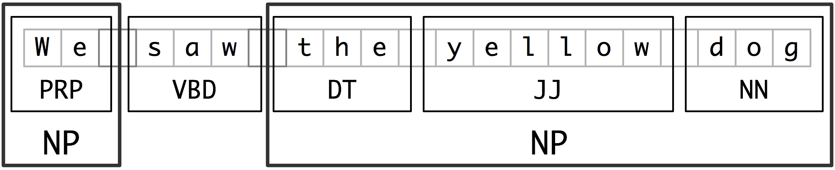

Figure 1: Sentence segmented in to Noun Phrases

The first noun phrase contains the pronoun 'We' and the second contains the phrase 'the yellow dog'. Here we can see that each noun phrase collects information in relation to a single noun entity. 'We' refers to the group of people looking at the 'dog'. We can also see from the second noun phrase that there is a description of the dog as yellow.

By chunking sentences in these noun phrases we can detect entities within the text as well as gaining further information about these entities.

Named Entity Recognition

Named Entity Recognition (NER) is a natural language processing technique. It is a subtask of information extraction and seeks to identify and locate named entities in a given text. While an exact definition of what constitutes a named entity is hard to pin down, the Conference on Computational Natural Language Learning (CoNLL-2002) provides the following definition.

“Named entities are phrases that contain the names of persons, organizations, locations, times and quantities.”

If we take the following sentence as an example:

Jim bought 300 shares of Microsoft in 2006.

A NER program should reproduce the sentence with annotations that highlight and classify the named entities, as seen below.

[Jim]_{person} bought 300 shares of [Microsoft]_{organisation} in [2006]_{time}.

The figure below illustrates the steps involved in detecting named entities.
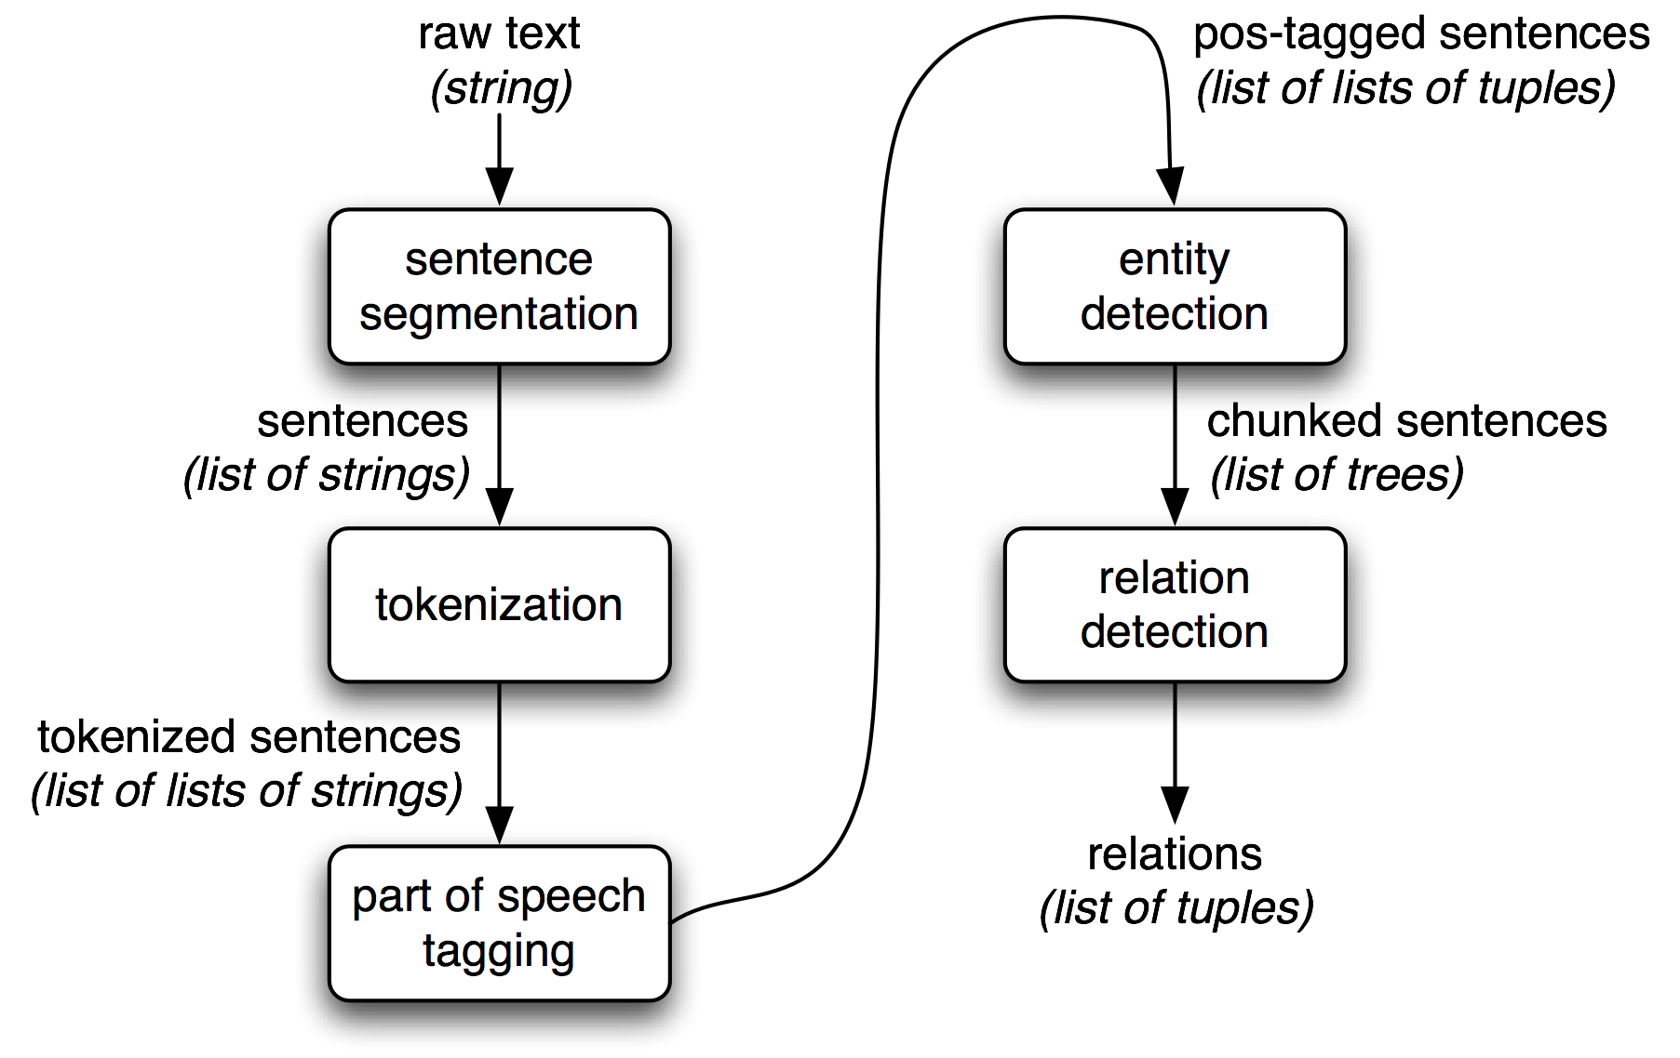
Figure 2: Architecture of named entity and relationship detection

Firstly the text is segmented in to sentences. The sentences are then tokenised in to words. The words are then tagged with an appropriate tag, i.e. noun verb etc. The tagged sentences are then chunked in to noun phrases and categorised. Lastly relationships can be detected from these noun phrases.

While there is no standardised method for evaluating NER systems, both CoNLL, the Conference on Natural Language Learning and MUC, the Message Understanding Conference, use an F1 measurement to evaluate the effectiveness of an NER system.

An F-measure is the harmonic mean between precision and recall. This is represented as follows:

Therefore,

The MUC-7 conferences defined precision and recall as follows:

Precision = COR/POS
Recall = COR/ACT

COR is the number of entities correctly tagged.
POS is the number of possible entities, i.e. the number of entities tagged by the system.
ACT is the number of actual entities within the test data.

The two human annotators at MUC-7 achieved F1 scores of 97.60% and 96.95%, while the best system at MUC-7 scored 93.39%, thereby achieving near-human performance.

Coreference Resolution

Coreference Resolution is a subtask of Information Extraction that seeks to identify all expressions in a text that refer to the same entity. This involves find references to the entity that may not use the entity's name. If we take the following two sentences as an example:

Jack visited Jill’s house. He made her dinner.

In this example the words 'Jack' and 'He' refer to the same entity. As do the words 'Jill' and 'her'.

